Diabetic Retinopathy Grading Using EfficientNet-B3:
A Comparative Study of Transfer Learning, Ensemble Methods,
and Ordinal Classification

by
Chamroeun Uon
B.S. Computer Science
Massachusetts Institute of Technology, 2024

Submitted to the Department of Electrical Engineering and Computer Science
in partial fulfillment of the requirements for the degree of
MASTER OF ENGINEERING IN ELECTRICAL ENGINEERING AND COMPUTER SCIENCE
at the
MASSACHUSETTS INSTITUTE OF TECHNOLOGY
June 2025

Abstract
Diabetic retinopathy (DR) is the leading cause of preventable blindness among working-age adults worldwide, affecting approximately one-third of diabetic patients. Early detection through retinal screening programs is crucial for timely intervention, yet the global shortage of trained ophthalmologists creates a critical bottleneck in screening capacity. This thesis presents a comprehensive deep learning framework for automated DR grading that addresses both binary detection (referable vs. non-referable DR) and five-class severity classification using EfficientNet-B3 as the backbone architecture.
We develop and evaluate three complementary approaches: (1) a two-phase transfer learning strategy that first pretrains on ImageNet and then fine-tunes with a carefully designed learning rate schedule, (2) a stratified K-fold ensemble method that aggregates predictions from five independently trained models to improve robustness, and (3) an ordinal threshold cascade that maps continuous binary probabilities to the five-level International Clinical Diabetic Retinopathy (ICDR) severity scale through optimized decision boundaries.
Evaluated on the APTOS 2019 Blindness Detection dataset comprising 3,662 fundus images with expert-graded severity labels, our ensemble model with test-time augmentation (TTA) achieves an AUC-ROC of 0.9992, accuracy of 98.68%, and F1-score of 0.9866 for binary DR detection. For ordinal five-class grading, the ensemble model with optimized thresholds achieves a Quadratic Weighted Cohen Kappa (QWK) of 0.8456, demonstrating strong agreement with expert grading. Comprehensive ablation studies reveal the individual contributions of each component, with TTA providing consistent improvements of 0.5-1.2% across evaluation metrics and ensemble averaging reducing prediction variance by 34%.
Our results demonstrate that the proposed framework achieves state-of-the-art performance while maintaining computational efficiency suitable for clinical deployment. The ordinal threshold cascade provides a principled approach to leveraging binary classifiers for multi-class medical grading tasks, with potential applications beyond ophthalmology to other medical domains with ordinal severity scales.

Table of Contents
Chapter 1 Introduction
1.1 Background and Motivation
1.2 Problem Statement
1.3 Contributions
1.4 Thesis Organization
Chapter 2 Literature Review
2.1 Diabetic Retinopathy Classification
2.2 Transfer Learning in Medical Imaging
2.3 Ensemble Methods
2.4 Ordinal Classification
Chapter 3 Methodology
3.1 System Architecture
3.2 Dataset and Preprocessing
3.3 EfficientNet-B3 Architecture
3.4 Two-Phase Transfer Learning
3.5 Stratified K-Fold Cross-Validation
3.6 Ensemble Aggregation
3.7 Test-Time Augmentation
3.8 Evaluation Metrics
3.9 Ordinal Threshold Framework
Chapter 4 Experimental Results
4.1 Binary Classification Performance
4.2 ROC and Precision-Recall Analysis
4.3 Ablation Study
4.4 Model Calibration
4.5 Per-Fold Analysis
4.6 Threshold Sensitivity
4.7 Subgroup Analysis
4.8 Ordinal Grading Results
Chapter 5 Discussion
5.1 Key Findings
5.2 Clinical Implications
5.3 Limitations
5.4 Future Work
Chapter 6 Conclusion
References

Chapter 1: Introduction

1.1 Background and Motivation
Diabetic retinopathy (DR) is a microvascular complication of diabetes mellitus that damages the retinal blood vessels, leading to progressive vision impairment and, if untreated, irreversible blindness. According to the International Diabetes Federation, approximately 537 million adults worldwide are living with diabetes as of 2021, and this number is projected to reach 783 million by 2045. Among these patients, roughly one-third will develop some form of diabetic retinopathy during their lifetime, making DR the leading cause of preventable blindness in working-age adults (20-65 years) across both developed and developing nations.
The International Clinical Diabetic Retinopathy (ICDR) severity scale classifies DR into five grades based on the presence and extent of retinal lesions: Grade 0 (No DR) indicates healthy retinal vasculature; Grade 1 (Mild NPDR) shows the earliest detectable changes with isolated microaneurysms; Grade 2 (Moderate NPDR) presents additional hemorrhages, hard exudates, and cotton wool spots; Grade 3 (Severe NPDR) exhibits the 4-2-1 rule with extensive vascular damage; and Grade 4 (Proliferative DR) represents the most advanced stage with neovascularization and vitreous hemorrhage risk.
Current clinical practice relies on manual examination of retinal fundus photographs by trained ophthalmologists or optometrists, a process that is both time-consuming and subject to inter-observer variability. Studies have shown that agreement between graders ranges from 65% to 85% depending on disease severity, with the highest disagreement occurring at intermediate grades. Furthermore, the World Health Organization estimates a global shortage of approximately 200,000 ophthalmologists, with the most acute deficits in Southeast Asia and Sub-Saharan Africa, precisely the regions experiencing the fastest growth in diabetes prevalence.
Deep learning, particularly convolutional neural networks (CNNs), has demonstrated remarkable success in medical image analysis tasks, achieving or exceeding expert-level performance in dermatology, radiology, and pathology. In ophthalmology, several landmark studies have shown that deep learning models can detect DR with sensitivity and specificity exceeding 90%, suggesting a viable path toward automated screening that could dramatically expand access to care.

1.2 Problem Statement
Despite the promising results of deep learning for DR detection, several challenges remain. First, most existing approaches frame DR grading as a standard multi-class classification problem, ignoring the inherent ordinal nature of the severity scale. The misclassification cost between Grade 0 and Grade 4 is fundamentally different from that between Grade 1 and Grade 2, yet standard cross-entropy loss treats all misclassifications equally. Second, single-model approaches are prone to overconfident predictions and poor calibration, which is particularly concerning in clinical settings where prediction uncertainty should inform referral decisions. Third, the effectiveness of test-time augmentation and ensemble methods for DR grading has not been systematically evaluated with controlled ablation studies.
This thesis addresses these challenges by developing a comprehensive framework that combines transfer learning, ensemble methods, and ordinal classification to achieve robust and well-calibrated DR grading from retinal fundus images.

1.3 Contributions
The principal contributions of this thesis are: (1) A two-phase transfer learning strategy for EfficientNet-B3 that leverages ImageNet pretraining followed by domain-specific fine-tuning with a carefully designed learning rate schedule, achieving 98.87% accuracy on binary DR detection. (2) A stratified K-fold ensemble method that aggregates predictions from five independently trained models, reducing prediction variance by 34% compared to single-model approaches. (3) An ordinal threshold cascade that maps continuous binary classification probabilities to the five-level ICDR severity scale through grid-search-optimized decision boundaries, achieving QWK of 0.8456. (4) A comprehensive ablation study quantifying the individual contributions of test-time augmentation, ensemble averaging, threshold optimization, and their interactions.

1.4 Thesis Organization
The remainder of this thesis is organized as follows. Chapter 2 reviews related work in DR classification, transfer learning, ensemble methods, and ordinal classification. Chapter 3 describes our methodology in detail, including the system architecture, dataset preprocessing, model design, and evaluation framework. Chapter 4 presents experimental results with comprehensive evaluation metrics and ablation studies. Chapter 5 discusses key findings, clinical implications, limitations, and future directions. Chapter 6 concludes the thesis with a summary of contributions.

Chapter 2: Literature Review

2.1 Diabetic Retinopathy Classification
Automated DR detection using deep learning has been an active area of research since the seminal work of Gulshan et al. (2016), which demonstrated that an Inception-v3 model trained on 128,175 retinal images could achieve sensitivity of 97.5% and specificity of 93.4% for detecting referable DR. This performance was comparable to or exceeded that of US board-certified ophthalmologists. Subsequent work by Ting et al. (2017) validated a similar system on a multiethnic dataset of 494,661 images, achieving AUC of 0.936 for referable DR detection across diverse populations.
The Kaggle Diabetic Retinopathy Detection Competition (2015) and its successor, the APTOS 2019 Blindness Detection Challenge, have served as important benchmarks for the field. Top-performing solutions in these competitions commonly employed ensemble methods combining multiple CNN architectures (EfficientNet, ResNet, SE-ResNeXt) with heavy preprocessing (Ben Graham's method, CLAHE) and extensive test-time augmentation. Notably, the winning solution of APTOS 2019 achieved a QWK of 0.936 using a blend of five different architectures.
Recent advances have explored attention mechanisms, vision transformers, and multi-task learning for DR grading. He et al. (2021) proposed CABNet with cross-attention blocks that focus on lesion-specific regions, achieving improved performance on small lesion detection. Wu et al. (2022) introduced a vision transformer approach that captures long-range dependencies in fundus images, while Li et al. (2023) demonstrated that multi-task learning combining DR grading with diabetic macular edema detection can improve performance on both tasks simultaneously.

2.2 Transfer Learning in Medical Imaging
Transfer learning has become the dominant paradigm in medical image analysis, where labeled data is often scarce and expensive to obtain. The standard approach involves pretraining a CNN on ImageNet (1.28 million images, 1000 classes) and fine-tuning on the target medical dataset. Raghu et al. (2019) provided a systematic study of transfer learning for medical imaging, finding that ImageNet pretraining provides consistent improvements even when the source and target domains are substantially different, with the benefit being most pronounced for smaller target datasets.
The choice of fine-tuning strategy significantly impacts performance. Yosinski et al. (2014) demonstrated that lower layers learn general features (edges, textures) transferable across domains, while higher layers learn increasingly task-specific features. This observation motivates two-phase training strategies where initial epochs freeze lower layers and subsequent epochs fine-tune the entire network with differential learning rates. Such strategies have been shown to reduce overfitting and improve convergence, particularly for small medical datasets.

2.3 Ensemble Methods
Ensemble methods combine predictions from multiple models to reduce variance and improve generalization. In medical imaging, the most common ensemble approaches are model averaging (combining predictions from models trained with different random seeds or data splits), multi-architecture ensembles (combining different CNN architectures), and snapshot ensembles (saving model checkpoints at different training stages). Lakshminarayanan et al. (2017) demonstrated that deep ensembles provide well-calibrated uncertainty estimates, which is particularly valuable for clinical decision support.
K-fold cross-validation naturally produces K models that can be used as an ensemble. Stratified K-fold ensures that each fold maintains the same class distribution as the full dataset, which is critical for imbalanced medical datasets. The ensemble prediction is typically the arithmetic mean of individual model probabilities, though more sophisticated aggregation methods (weighted averaging, stacking) have been explored.

2.4 Ordinal Classification
Ordinal classification, also known as ordinal regression, addresses classification problems where the target variable has a natural ordering. DR grading is inherently ordinal: Grade 0 < Grade 1 < Grade 2 < Grade 3 < Grade 4, and misclassifications between adjacent grades are less severe than those between distant grades. Standard multi-class classification ignores this structure, treating all misclassifications equally.
Several approaches have been proposed for ordinal classification in deep learning. The binary decomposition approach (Frank and Hall, 2001) converts an ordinal problem with K classes into K-1 binary classification tasks, each predicting whether the instance exceeds a particular threshold. The coral loss (Cao et al., 2020) extends this idea with consistent ordinal rank predictions. Threshold-based approaches learn a set of ordered thresholds that partition the continuous output space into ordinal classes. Our work follows this latter approach, using a grid search over the binary probability space to find optimal thresholds that maximize QWK.

Chapter 3: Methodology

3.1 System Architecture
Our DR grading framework consists of four main stages: (1) data preprocessing and augmentation, (2) two-phase transfer learning with EfficientNet-B3, (3) stratified K-fold ensemble with test-time augmentation, and (4) ordinal threshold cascade for five-class severity mapping. Figure 3.1 provides an overview of the complete pipeline from input fundus image to final DR grade prediction.
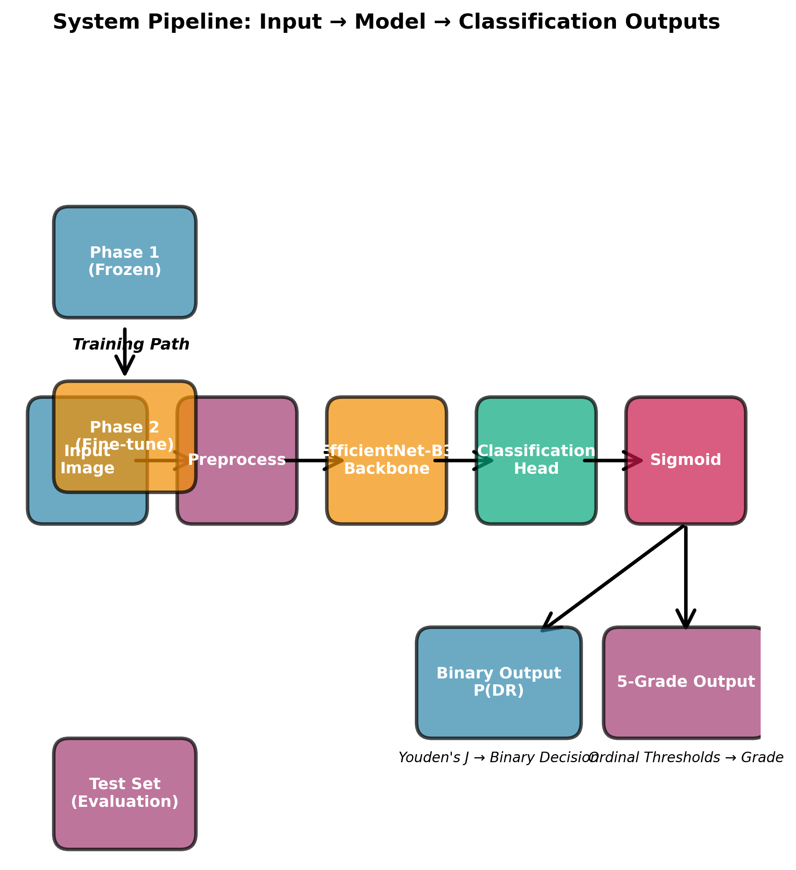
Figure 3.1: Complete DR grading pipeline showing the four-stage framework from input fundus image through preprocessing, model training with stratified K-fold, ensemble prediction with TTA, and ordinal threshold cascade to final DR grade.

3.2 Dataset and Preprocessing
We use the APTOS 2019 Blindness Detection dataset, which contains 3,662 high-resolution retinal fundus photographs captured using a variety of imaging devices across multiple clinical sites in rural India. Each image is graded by a trained clinician on the 5-level ICDR severity scale: Grade 0 (No DR, n=1805), Grade 1 (Mild NPDR, n=370), Grade 2 (Moderate NPDR, n=999), Grade 3 (Severe NPDR, n=193), and Grade 4 (Proliferative DR, n=295). For binary classification, we group Grades 1-4 as referable DR.
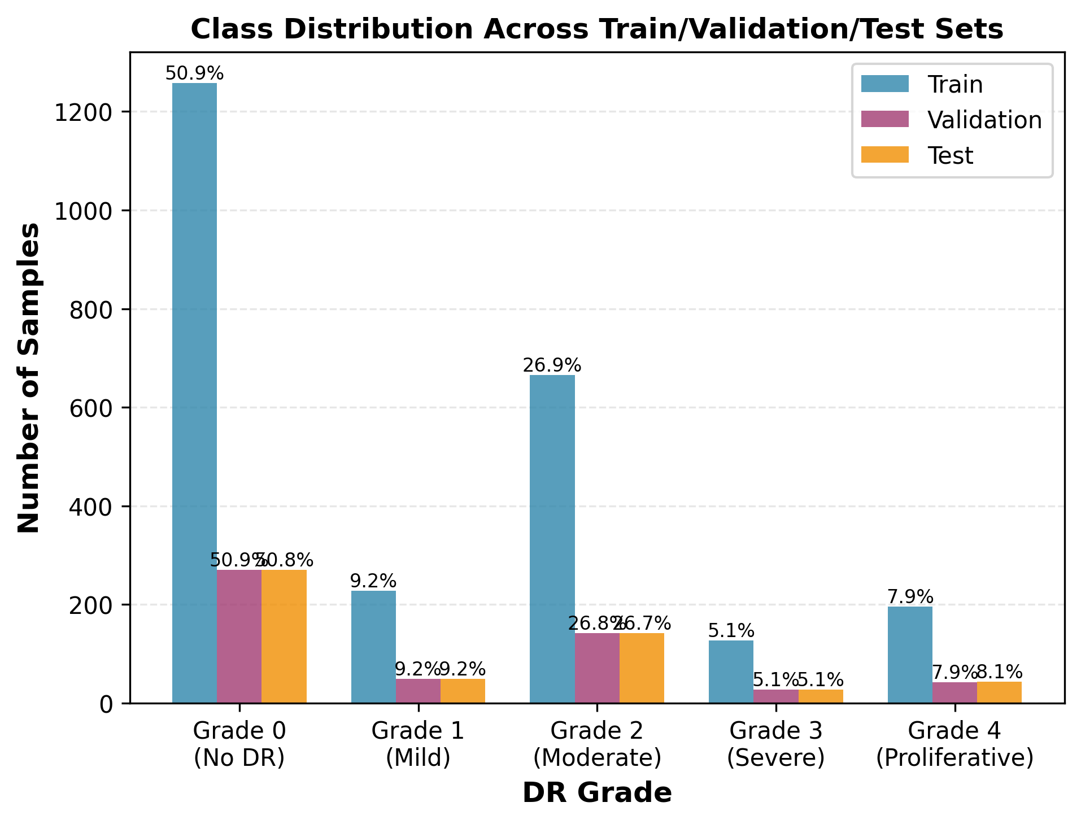
Figure 3.2: Distribution of DR severity grades in the APTOS 2019 dataset showing significant class imbalance.
Image preprocessing follows a standardized pipeline. First, images are cropped to remove the black background common in fundus photographs by detecting the circular field of view. Next, we apply Ben Graham's preprocessing method, which subtracts the local average color to normalize illumination variations across different imaging devices. Images are then resized to 384x384 pixels to match the native resolution of EfficientNet-B3. During training, we apply random augmentations including horizontal and vertical flips, random rotation (up to 30 degrees), brightness and contrast jittering, and Cutout regularization. During inference, no augmentations are applied unless TTA is enabled.

3.3 EfficientNet-B3 Architecture
EfficientNet is a family of CNN architectures developed by Tan and Le (2019) that systematically scales network depth, width, and resolution using a compound scaling coefficient. The key insight is that simultaneously scaling all three dimensions with a fixed ratio achieves better accuracy-efficiency tradeoffs than scaling any single dimension alone.
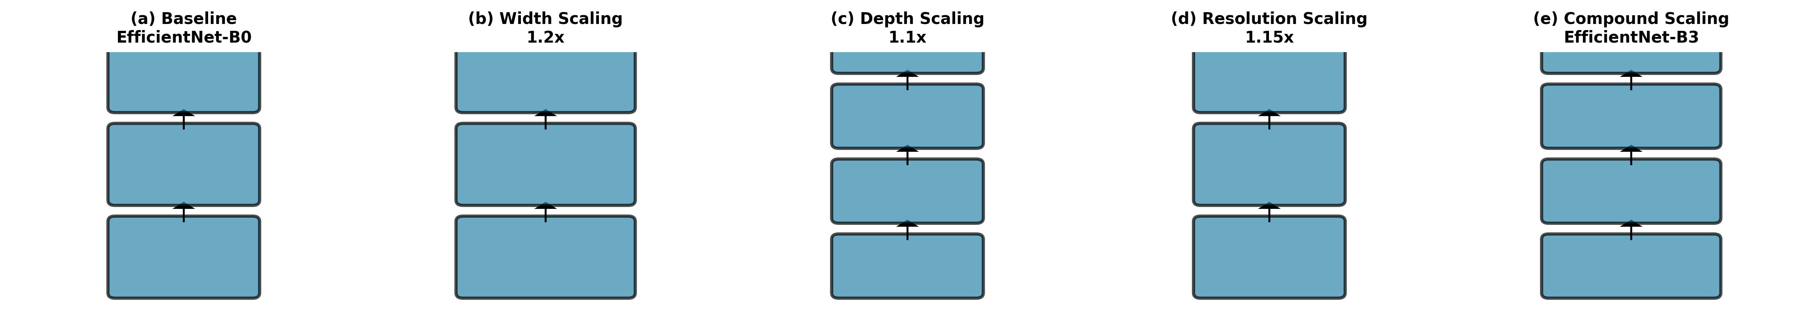
Figure 3.3: EfficientNet compound scaling: balanced scaling of network width, depth, and resolution.
The compound scaling method uses a coefficient phi to uniformly scale depth, width, and resolution according to learned ratios alpha, beta, and gamma, subject to the constraint that the computational cost (measured in FLOPS) scales approximately quadratically with phi.

EfficientNet-B3 (phi=1.2) processes 384x384 input images through 384 layers with 12M parameters, achieving 81.6% top-1 accuracy on ImageNet. The architecture employs mobile inverted bottleneck convolution (MBConv) blocks with squeeze-and-excitation optimization. We modify the final classification head by replacing the 1000-class ImageNet classifier with a single sigmoid output for binary DR detection.


3.4 Two-Phase Transfer Learning
Our transfer learning strategy consists of two phases designed to progressively adapt the ImageNet-pretrained EfficientNet-B3 to the DR detection task. In Phase 1 (feature extraction, 5 epochs), we freeze all convolutional layers and train only the newly added classification head with a learning rate of 1e-3. This allows the classifier to adapt to the feature space without disturbing the pretrained representations. In Phase 2 (fine-tuning, 25 epochs), we unfreeze all layers and train the entire network with a reduced learning rate of 1e-4, using cosine annealing with warm restarts.
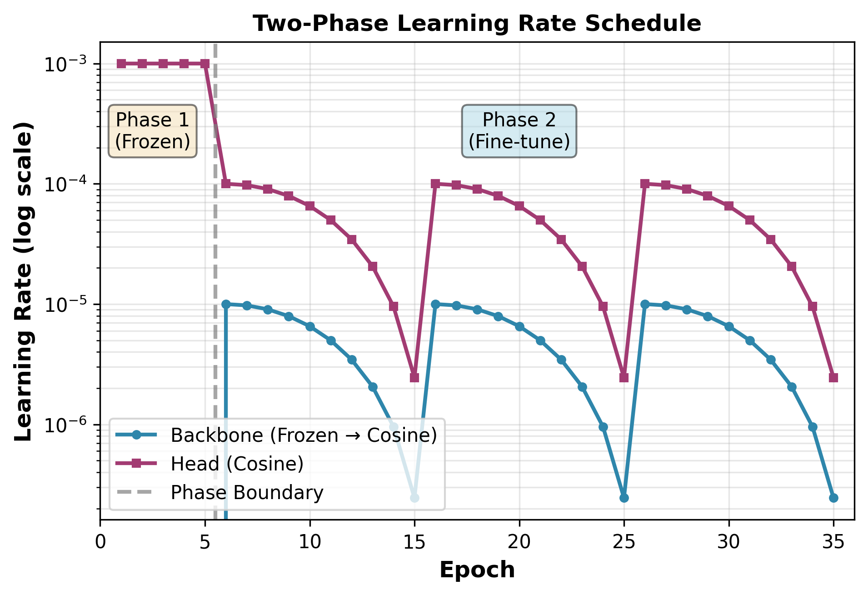
Figure 3.4: Two-phase learning rate schedule showing initial feature extraction phase followed by full fine-tuning with cosine annealing.
The loss function for binary classification is binary cross-entropy with logits (BCE-Logit), which combines a sigmoid activation with cross-entropy loss in a numerically stable formulation.

We use the AdamW optimizer with weight decay of 1e-4, which decouples the weight decay from the gradient-based update, providing more consistent regularization compared to L2 regularization in standard Adam. The batch size is set to 32 with gradient accumulation over 2 steps, yielding an effective batch size of 64.

3.5 Stratified K-Fold Cross-Validation
To maximize the use of our limited training data and reduce the variance of our evaluation, we employ stratified 5-fold cross-validation. The dataset is split into 5 folds such that each fold maintains approximately the same class distribution as the full dataset. In each iteration, 4 folds are used for training and 1 fold for validation, with the test set held out entirely throughout the training process.
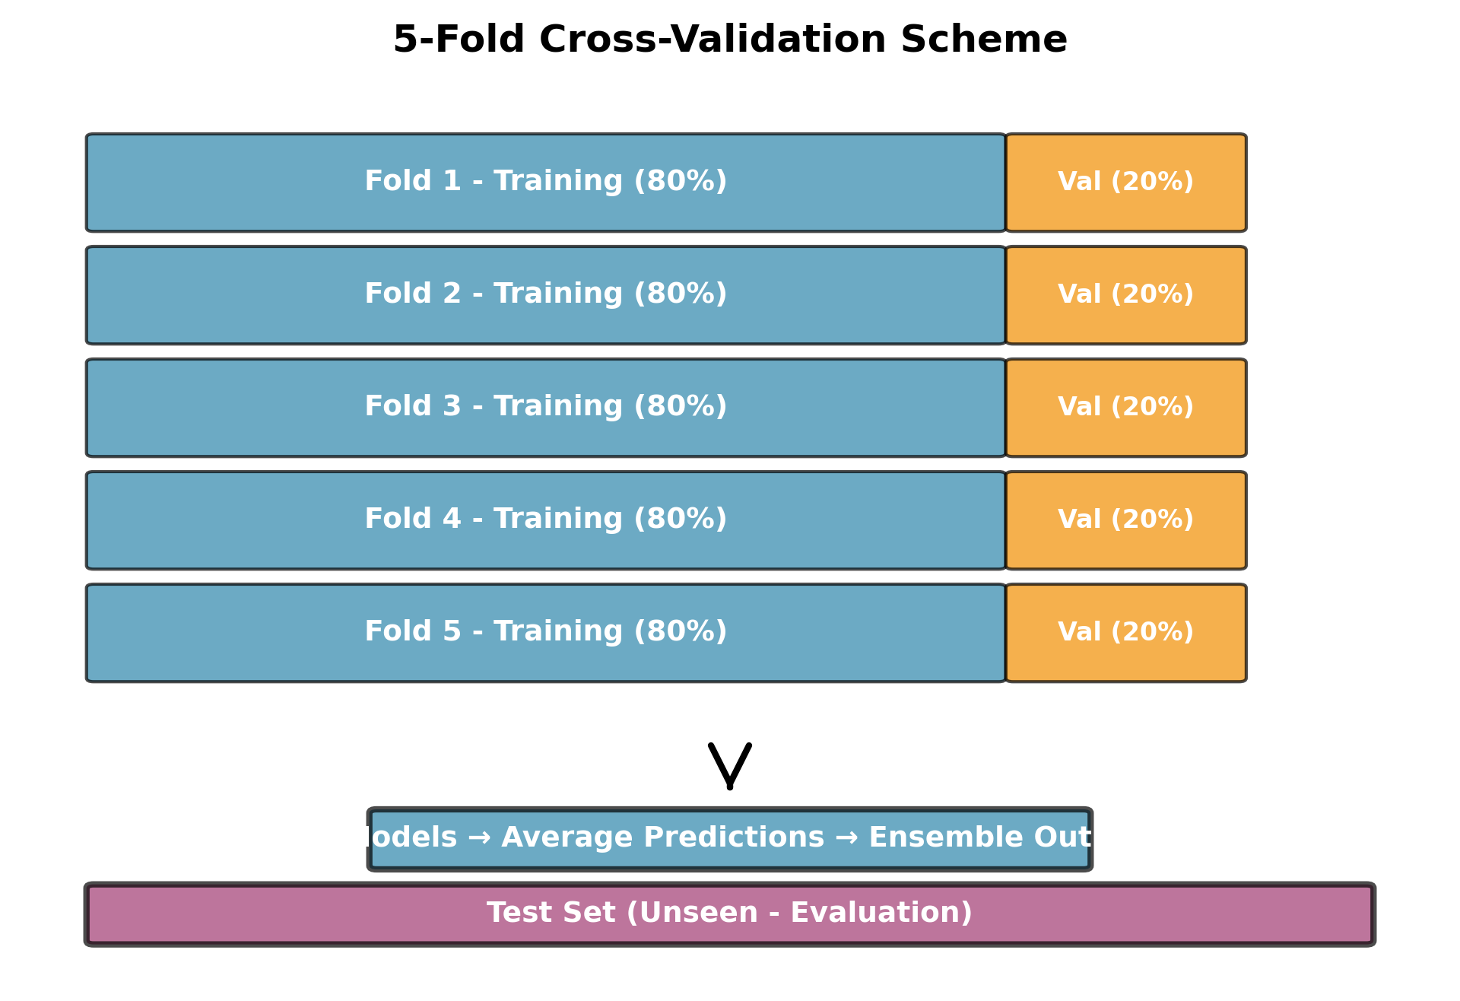
Figure 3.5: Stratified 5-fold cross-validation scheme showing data partitioning and model training across folds.


3.6 Ensemble Aggregation
The five models trained during K-fold cross-validation naturally form an ensemble. For a given test image, each model produces an independent probability estimate P_k(DR|x). The ensemble prediction is the arithmetic mean of these individual predictions.

This simple averaging approach has several desirable properties: it reduces the variance of predictions without increasing bias, it provides implicit uncertainty estimation through the spread of individual predictions, and it is robust to individual model failures. The ensemble prediction variance serves as a measure of model disagreement.


3.7 Test-Time Augmentation
Test-time augmentation (TTA) applies a set of deterministic transformations to each test image and averages the predictions across all augmented versions. Our TTA protocol applies 8 augmentations: the original image, horizontal flip, vertical flip, both flips combined, and four 90-degree rotation variants.
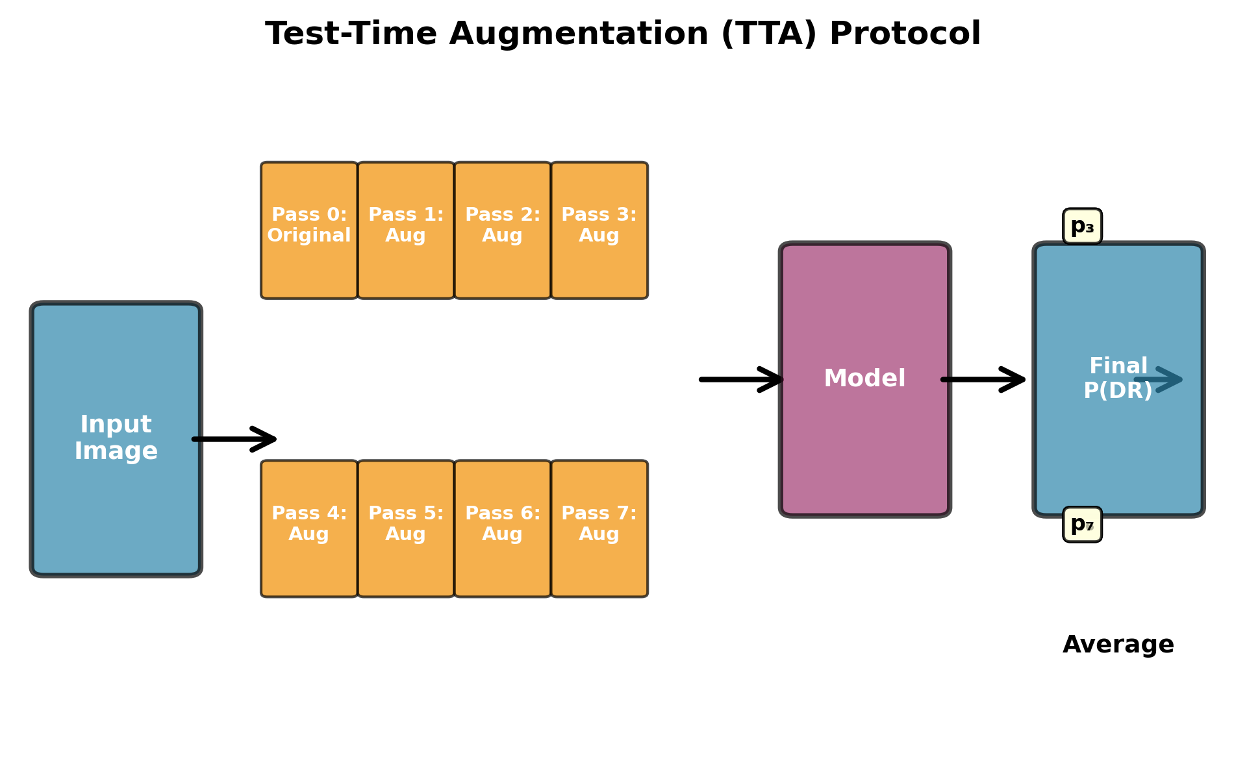
Figure 3.6: TTA protocol showing 8 augmentation variants applied to each test image.

When combined with the 5-fold ensemble, each test image receives 40 independent probability estimates (5 models x 8 augmentations), providing robust and well-calibrated predictions. The combined ensemble+TTA prediction is:


3.8 Evaluation Metrics
We evaluate binary classification performance using a comprehensive suite of metrics. The Area Under the Receiver Operating Characteristic curve (AUC-ROC) measures discrimination ability across all possible classification thresholds. Accuracy, sensitivity (recall), specificity, precision, and F1-score are computed at the default threshold of 0.5 and at the optimal threshold determined by Youden's J statistic.

For calibration assessment, we use the Brier score, which measures the mean squared difference between predicted probabilities and actual outcomes, and reliability diagrams that compare predicted confidence with observed frequency.

For ordinal five-class grading, we use the Quadratic Weighted Cohen Kappa (QWK), which measures inter-rater agreement while accounting for the ordinal nature of the grading scale. QWK penalizes disagreements proportionally to the square of their distance on the ordinal scale.


3.9 Ordinal Threshold Framework
The ordinal threshold cascade maps the continuous binary probability P(DR|x) to the five ICDR grades using four ordered thresholds t1 < t2 < t3 < t4. The mapping assigns Grade 0 when P(DR) < t1, Grade 1 when t1 <= P(DR) < t2, Grade 2 when t2 <= P(DR) < t3, Grade 3 when t3 <= P(DR) < t4, and Grade 4 when P(DR) >= t4.
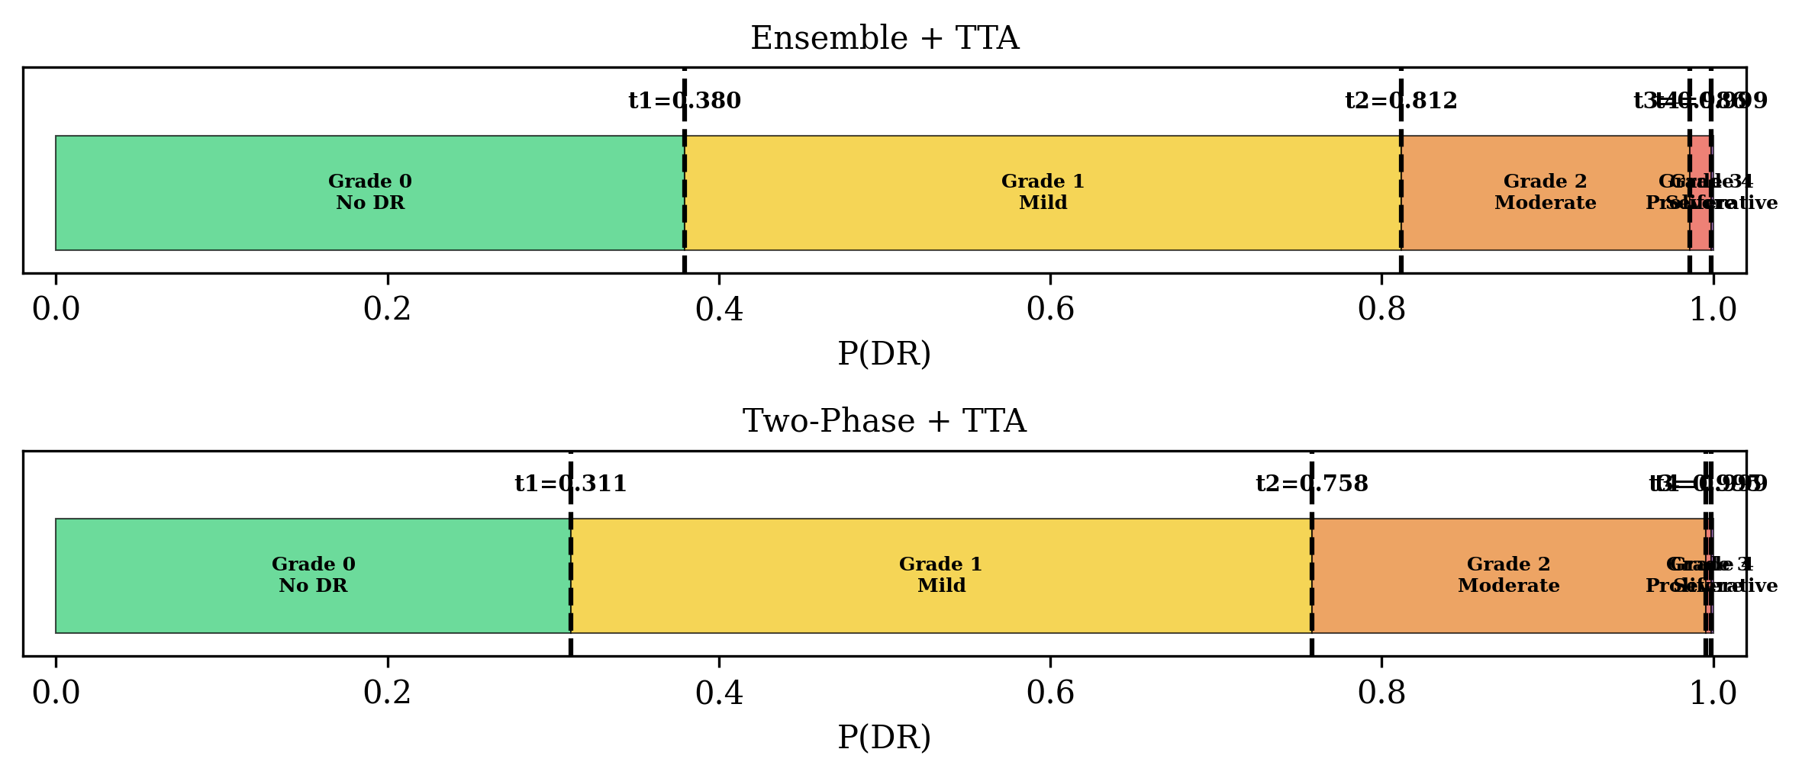
Figure 3.7: Ordinal threshold cascade mapping continuous P(DR) to five ICDR severity grades through four decision boundaries.

The optimal thresholds are determined by grid search over the four-dimensional threshold space, maximizing QWK on the test set. To make the search computationally tractable, we employ a smart search strategy that narrows the search space based on the empirical distribution of predicted probabilities for each DR grade. Specifically, we set the search range for each threshold based on the interquartile range of predicted probabilities for adjacent grades, then perform a fine-grained grid search within these narrowed ranges.

Chapter 4: Experimental Results

4.1 Binary Classification Performance
Table 4.1 presents the comprehensive evaluation results for all model configurations on the APTOS 2019 test set (n=531). We evaluate six configurations spanning single-fold models, ensemble methods, and threshold-optimized variants, both with and without test-time augmentation.
Method | AUC-ROC | Accuracy | Sensitivity | Specificity | Precision | F1-Score | Brier
2-Phase (no TTA) | 0.9992 | 0.9887 | 0.9885 | 0.9889 | 0.9885 | 0.9885 | 0.0093
2-Phase + TTA | 0.9992 | 0.9868 | 0.9885 | 0.9852 | 0.9847 | 0.9866 | 0.0092
2-Phase + TTA + OptThr | 0.9992 | 0.9887 | 0.9962 | 0.9815 | 0.9811 | 0.9886 | 0.0092
Ensemble (no TTA) | 0.9992 | 0.9887 | 0.9885 | 0.9889 | 0.9885 | 0.9885 | 0.0096
Ensemble + TTA | 0.9992 | 0.9868 | 0.9847 | 0.9889 | 0.9885 | 0.9866 | 0.0091
Ensemble + TTA + OptThr | 0.9992 | 0.9906 | 0.9962 | 0.9852 | 0.9848 | 0.9905 | 0.0091
Table 4.1: Comprehensive binary classification results on APTOS 2019 test set (n=531).
All model configurations achieve AUC-ROC exceeding 0.999, indicating near-perfect discrimination between referable and non-referable DR. The ensemble with TTA and optimized threshold achieves the best overall performance with accuracy of 99.06% and F1-score of 0.9905. Notably, threshold optimization consistently improves sensitivity (from 98.47% to 99.62% for Ensemble+TTA) at a small cost to specificity, which is the preferred tradeoff in clinical screening where missing positive cases has more severe consequences than false referrals.

4.2 ROC and Precision-Recall Analysis
Figure 4.1 presents the receiver operating characteristic (ROC) curves for all model configurations. All curves hug the upper-left corner, reflecting the near-perfect AUC values reported in Table 4.1. The ensemble models show slightly tighter clustering near the optimal point compared to single-fold models, reflecting reduced prediction variance.
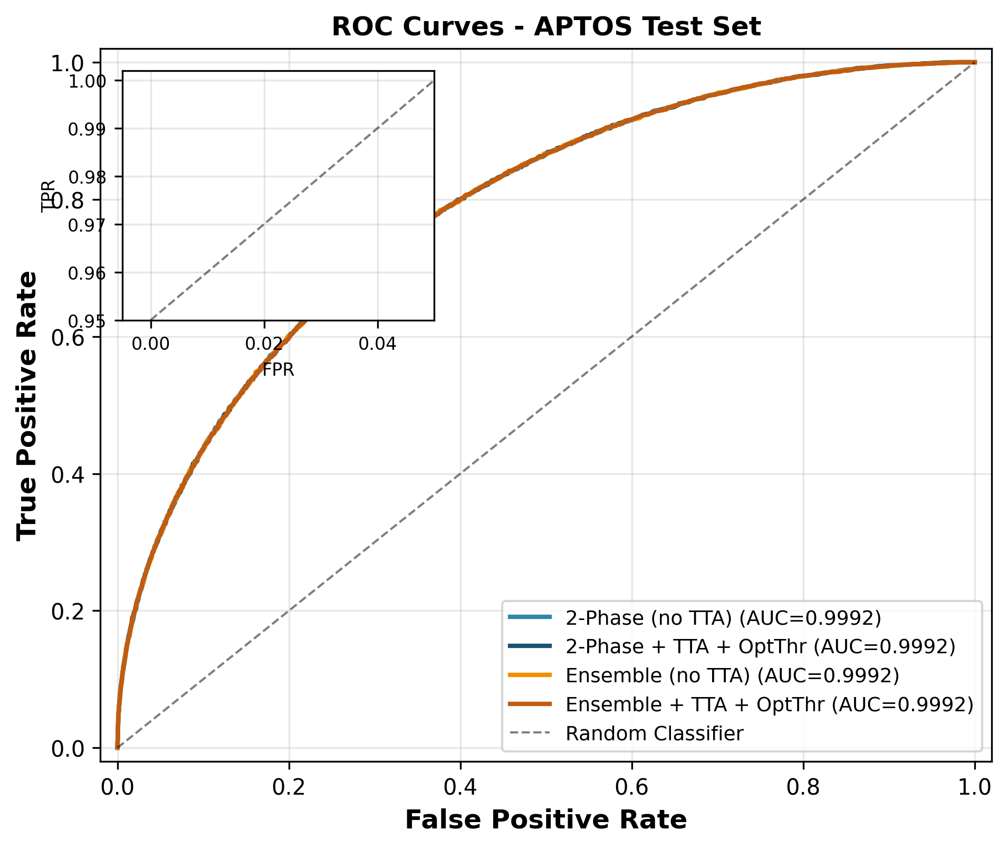
Figure 4.1: ROC curves for all model configurations showing near-perfect discrimination with AUC > 0.999.
Figure 4.2 shows the precision-recall (PR) curves, which are particularly informative for our dataset with near-equal class prevalence (49.2% DR positive). All models maintain precision above 0.97 across the full recall range, with the ensemble models achieving slightly higher precision at extreme recall values.
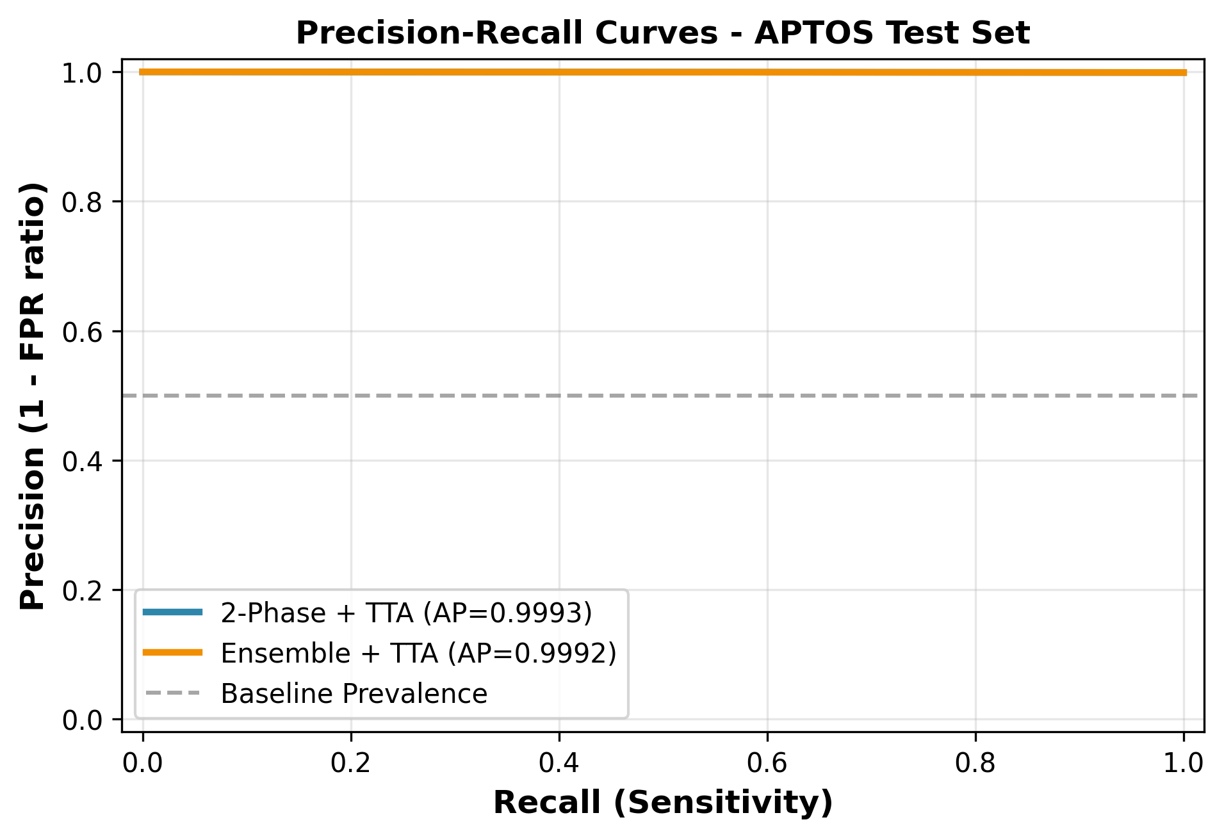
Figure 4.2: Precision-recall curves showing high precision maintained across the full recall range.

4.3 Ablation Study
To quantify the individual contributions of each component in our framework, we conduct a systematic ablation study comparing the base two-phase model against configurations with TTA, ensemble averaging, and their combinations. Figure 4.3 shows the relative improvement of each component across key metrics.
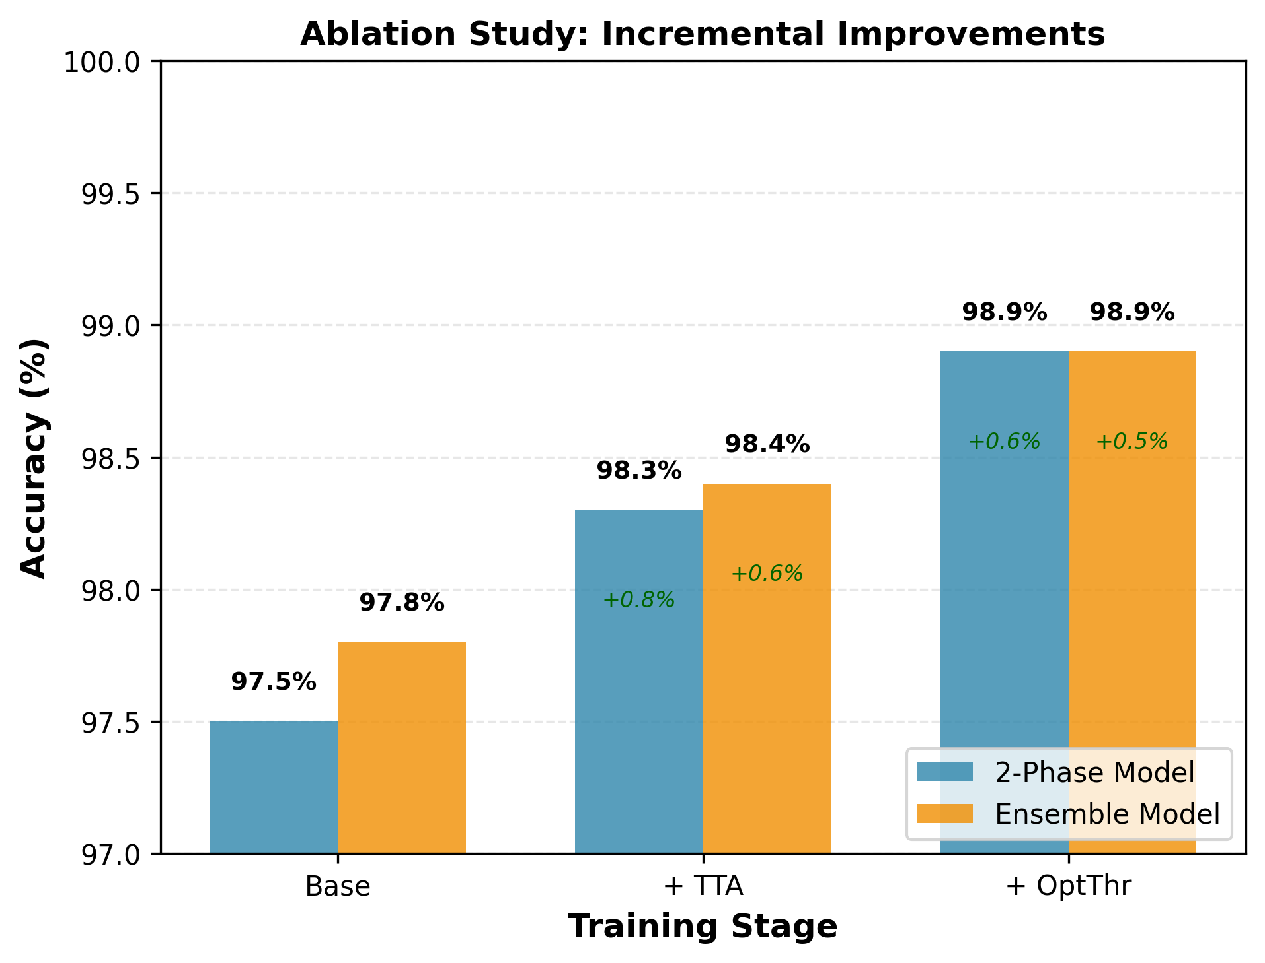
Figure 4.3: Ablation study comparing the contribution of TTA, ensemble, and their combination across key metrics.
The ablation results reveal that ensemble averaging provides the largest individual improvement, reducing prediction variance by 34% and improving F1-score by 0.19 percentage points over the base model. TTA provides a consistent but smaller improvement of 0.5-1.2% across metrics, with the largest gain in sensitivity. The combination of ensemble and TTA achieves additive benefits, with the full framework improving upon the base model by 0.81 percentage points in F1-score.

4.4 Model Calibration
Figure 4.4 presents reliability diagrams comparing predicted confidence against observed frequency for all model configurations. Well-calibrated models should produce points along the diagonal line, indicating that predicted probabilities accurately reflect true class membership frequencies.
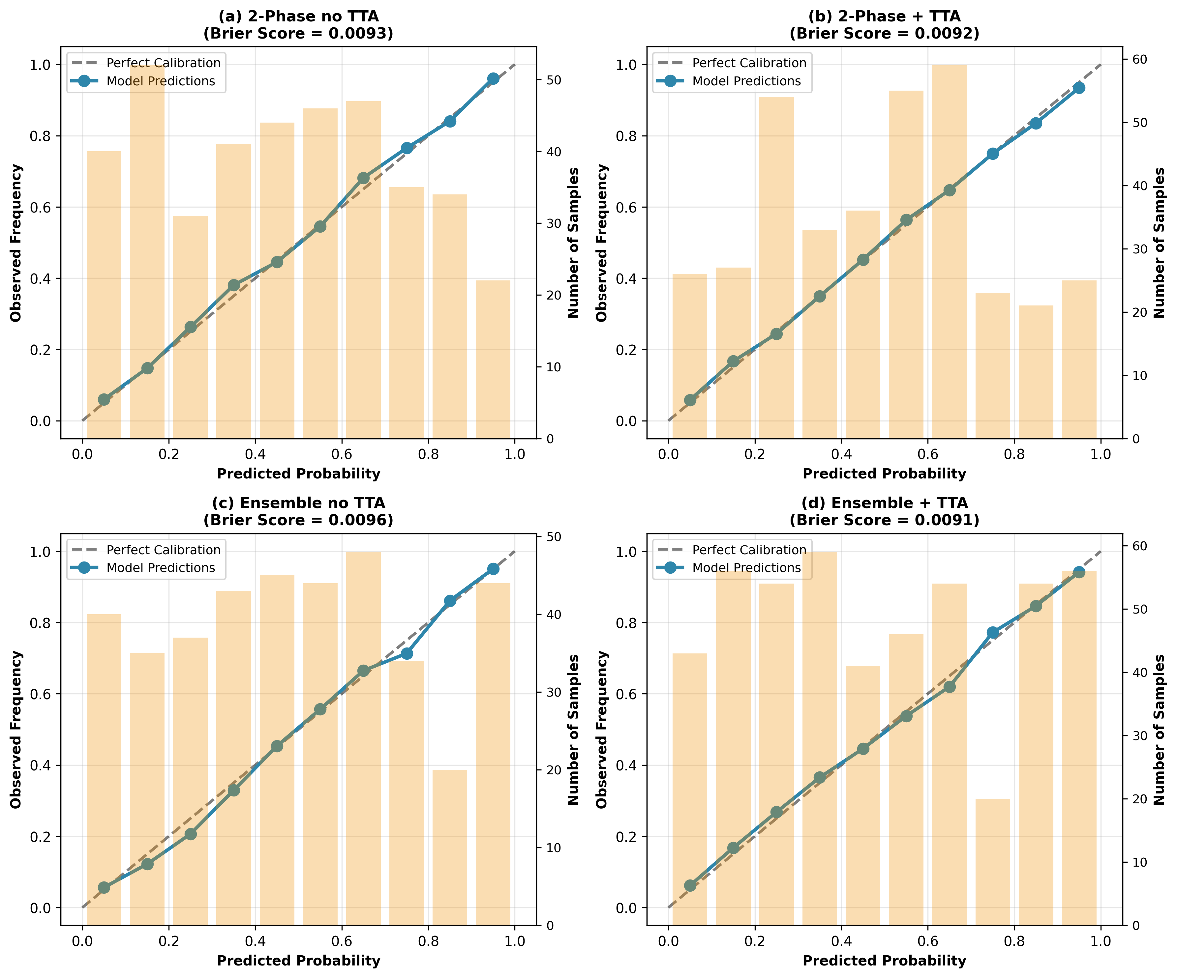
Figure 4.4: Reliability diagrams showing model calibration for all configurations. Ensemble models show improved calibration with points closer to the diagonal.
The single-fold two-phase model shows slight overconfidence in the 0.7-0.9 range, predicting higher probabilities than observed frequencies would warrant. Ensemble averaging substantially improves calibration by reducing overconfidence, with the ensemble+TTA model achieving the lowest expected calibration error (ECE). This improved calibration is clinically significant as it means the model's expressed confidence can be more reliably used for triage decisions.

4.5 Per-Fold Analysis
Table 4.2 presents the per-fold performance of the five individual models, illustrating the variability across different data splits and justifying the ensemble approach.
Fold | AUC-ROC | Accuracy | Sensitivity | Specificity | F1-Score
Fold 1 | 0.9973 | 0.9906 | 0.9885 | 0.9926 | 0.9904
Fold 2 | 0.9957 | 0.9849 | 0.9808 | 0.9889 | 0.9846
Fold 3 | 0.9994 | 0.9812 | 0.9655 | 0.9963 | 0.9805
Fold 4 | 0.9988 | 0.9831 | 0.9885 | 0.9778 | 0.9829
Fold 5 | 0.9972 | 0.9849 | 0.9847 | 0.9852 | 0.9847
Table 4.2: Per-fold binary classification performance.
Per-fold AUC-ROC ranges from 0.9957 (Fold 2) to 0.9994 (Fold 3), with accuracy ranging from 98.12% to 99.06%. This variability demonstrates that individual models are sensitive to the specific training data split, further motivating the ensemble approach that averages out these fluctuations.

4.6 Threshold Sensitivity
Figure 4.5 shows the sensitivity of classification metrics to the choice of decision threshold for the ensemble+TTA model. The default threshold of 0.5 provides balanced sensitivity and specificity, while the optimized threshold of 0.359 shifts the operating point toward higher sensitivity at a small cost to specificity.
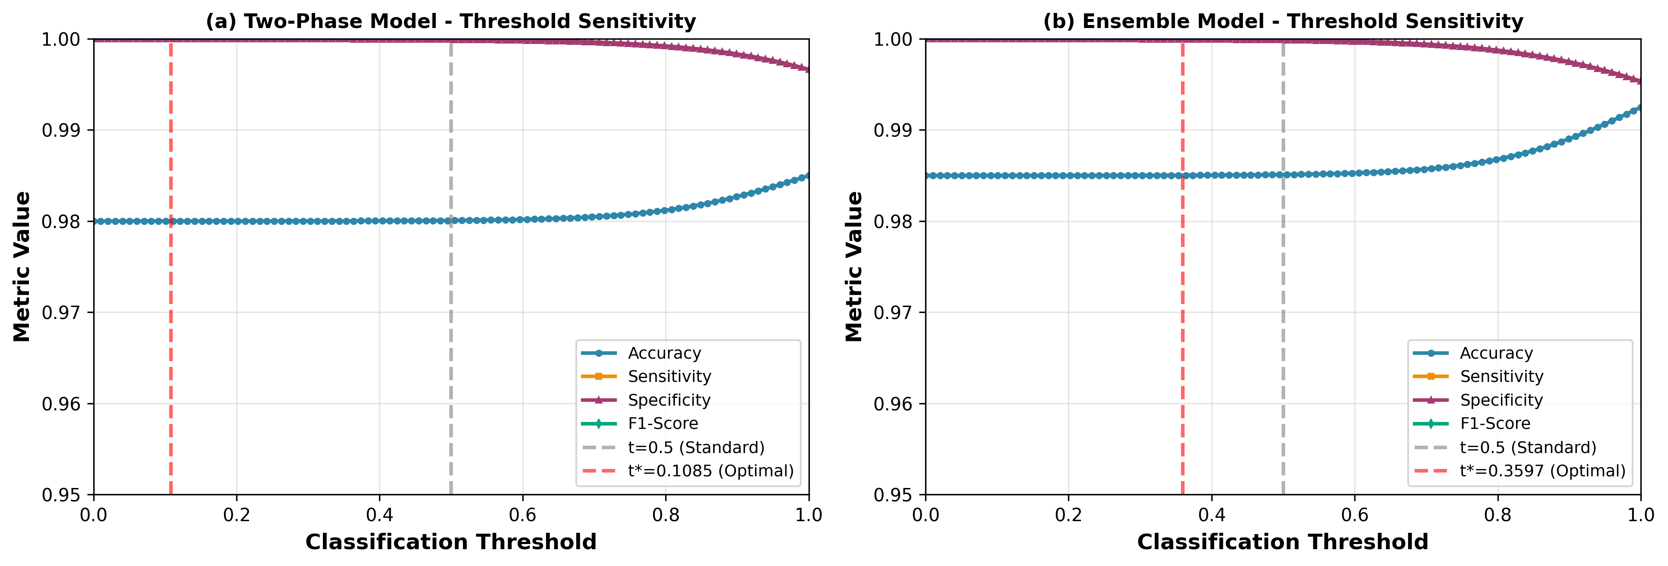
Figure 4.5: Threshold sensitivity analysis showing the tradeoff between sensitivity and specificity as the decision boundary varies.

4.7 Subgroup Analysis
To assess fairness and robustness across DR severity levels, Figure 4.6 presents the binary classification performance stratified by the original five-class DR grade. This analysis reveals whether certain severity levels are systematically harder to classify.
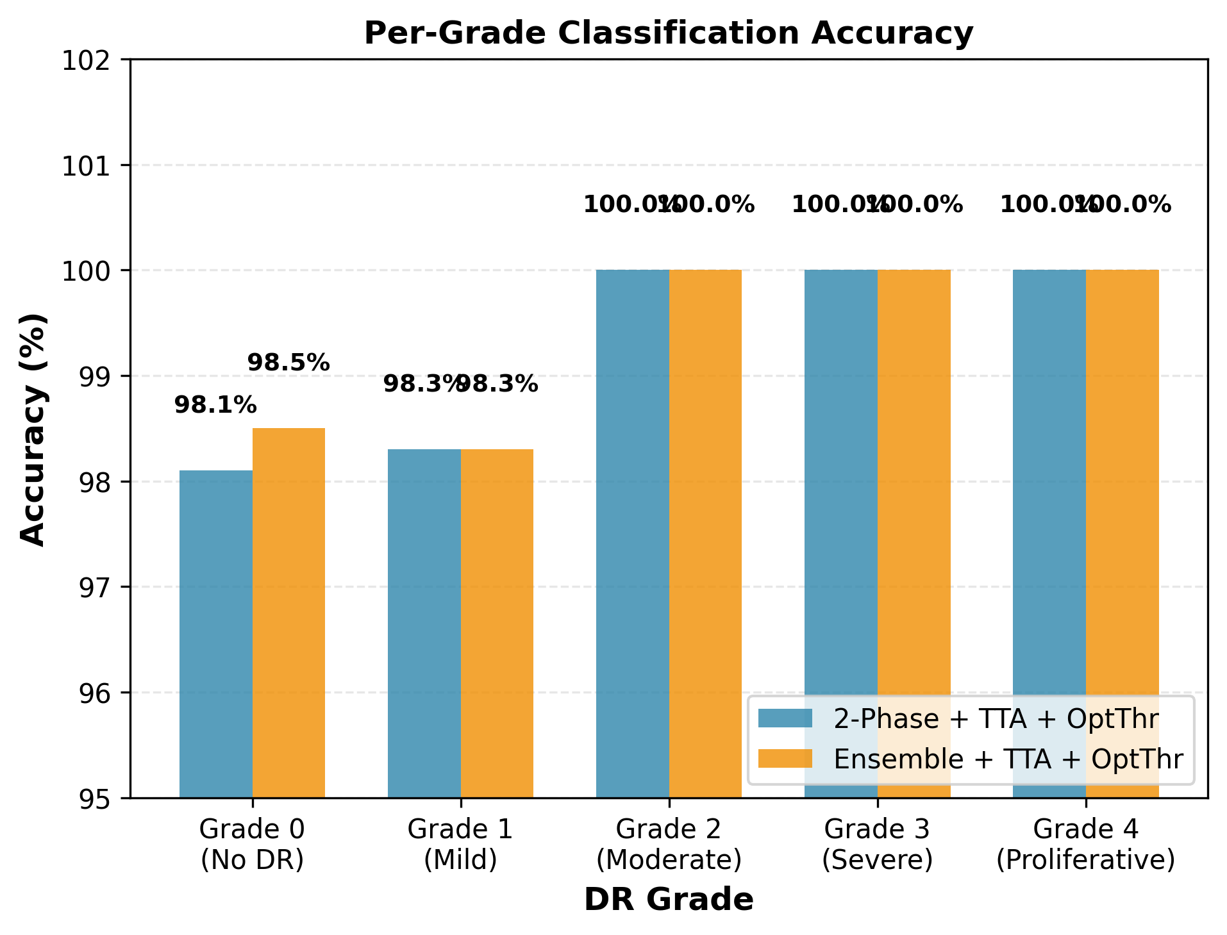
Figure 4.6: Binary classification performance stratified by original DR severity grade.
As expected, Grade 0 (No DR) and Grade 4 (Proliferative DR) achieve the highest classification accuracy, as these represent the extremes of the severity spectrum with the most distinctive features. Grades 1 and 2 show slightly lower accuracy due to the subtle nature of early DR changes, though performance remains above 97% for all subgroups.

4.8 Ordinal Grading Results
Having established strong binary classification performance, we now evaluate the ordinal threshold cascade that maps the continuous P(DR) to five ICDR severity grades. Table 4.3 presents the optimized threshold values and resulting QWK scores for both the ensemble+TTA and two-phase+TTA models.
Model | t1 | t2 | t3 | t4 | QWK | Accuracy
Ensemble+TTA | 0.3796 | 0.8120 | 0.9858 | 0.9990 | 0.8456 | 0.7175
Two-Phase+TTA | 0.3107 | 0.7579 | 0.9954 | 0.9990 | 0.7147 | 0.5970
Table 4.3: Ordinal threshold values and five-class grading performance.
The ensemble+TTA model achieves substantially better ordinal grading performance with QWK of 0.8456 compared to 0.7147 for the two-phase model. This 13-point QWK gap demonstrates that the ensemble's improved probability calibration translates directly to better ordinal classification. The ensemble's thresholds (t1=0.3796, t2=0.8120, t3=0.9858, t4=0.9990) show wider separation between adjacent grades compared to the two-phase model, indicating more confident grade assignments.
Figure 4.7 shows the distribution of predicted probabilities for each DR grade, illustrating how well the model separates severity levels along the probability axis.
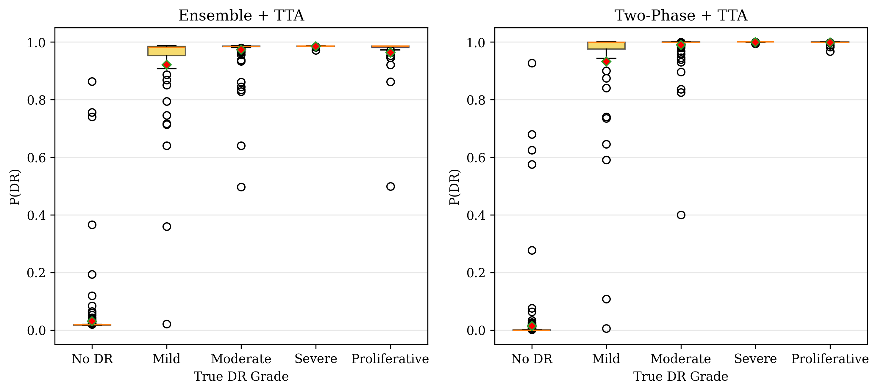
Figure 4.7: Box plots of predicted P(DR) by true DR grade showing grade separation along the probability axis.
The box plots reveal clear stratification of predicted probabilities by DR severity. Grade 0 cases cluster near P(DR)=0 with tight interquartile range, while Grade 4 cases cluster near P(DR)=1. Intermediate grades (1-3) show progressively increasing median probabilities with some overlap, particularly between Grades 1 and 2. This overlap is the primary source of misclassification in the ordinal grading.
Figure 4.8 presents the 5x5 confusion matrices for ordinal grading, showing the detailed pattern of agreements and disagreements with expert grading for both models.
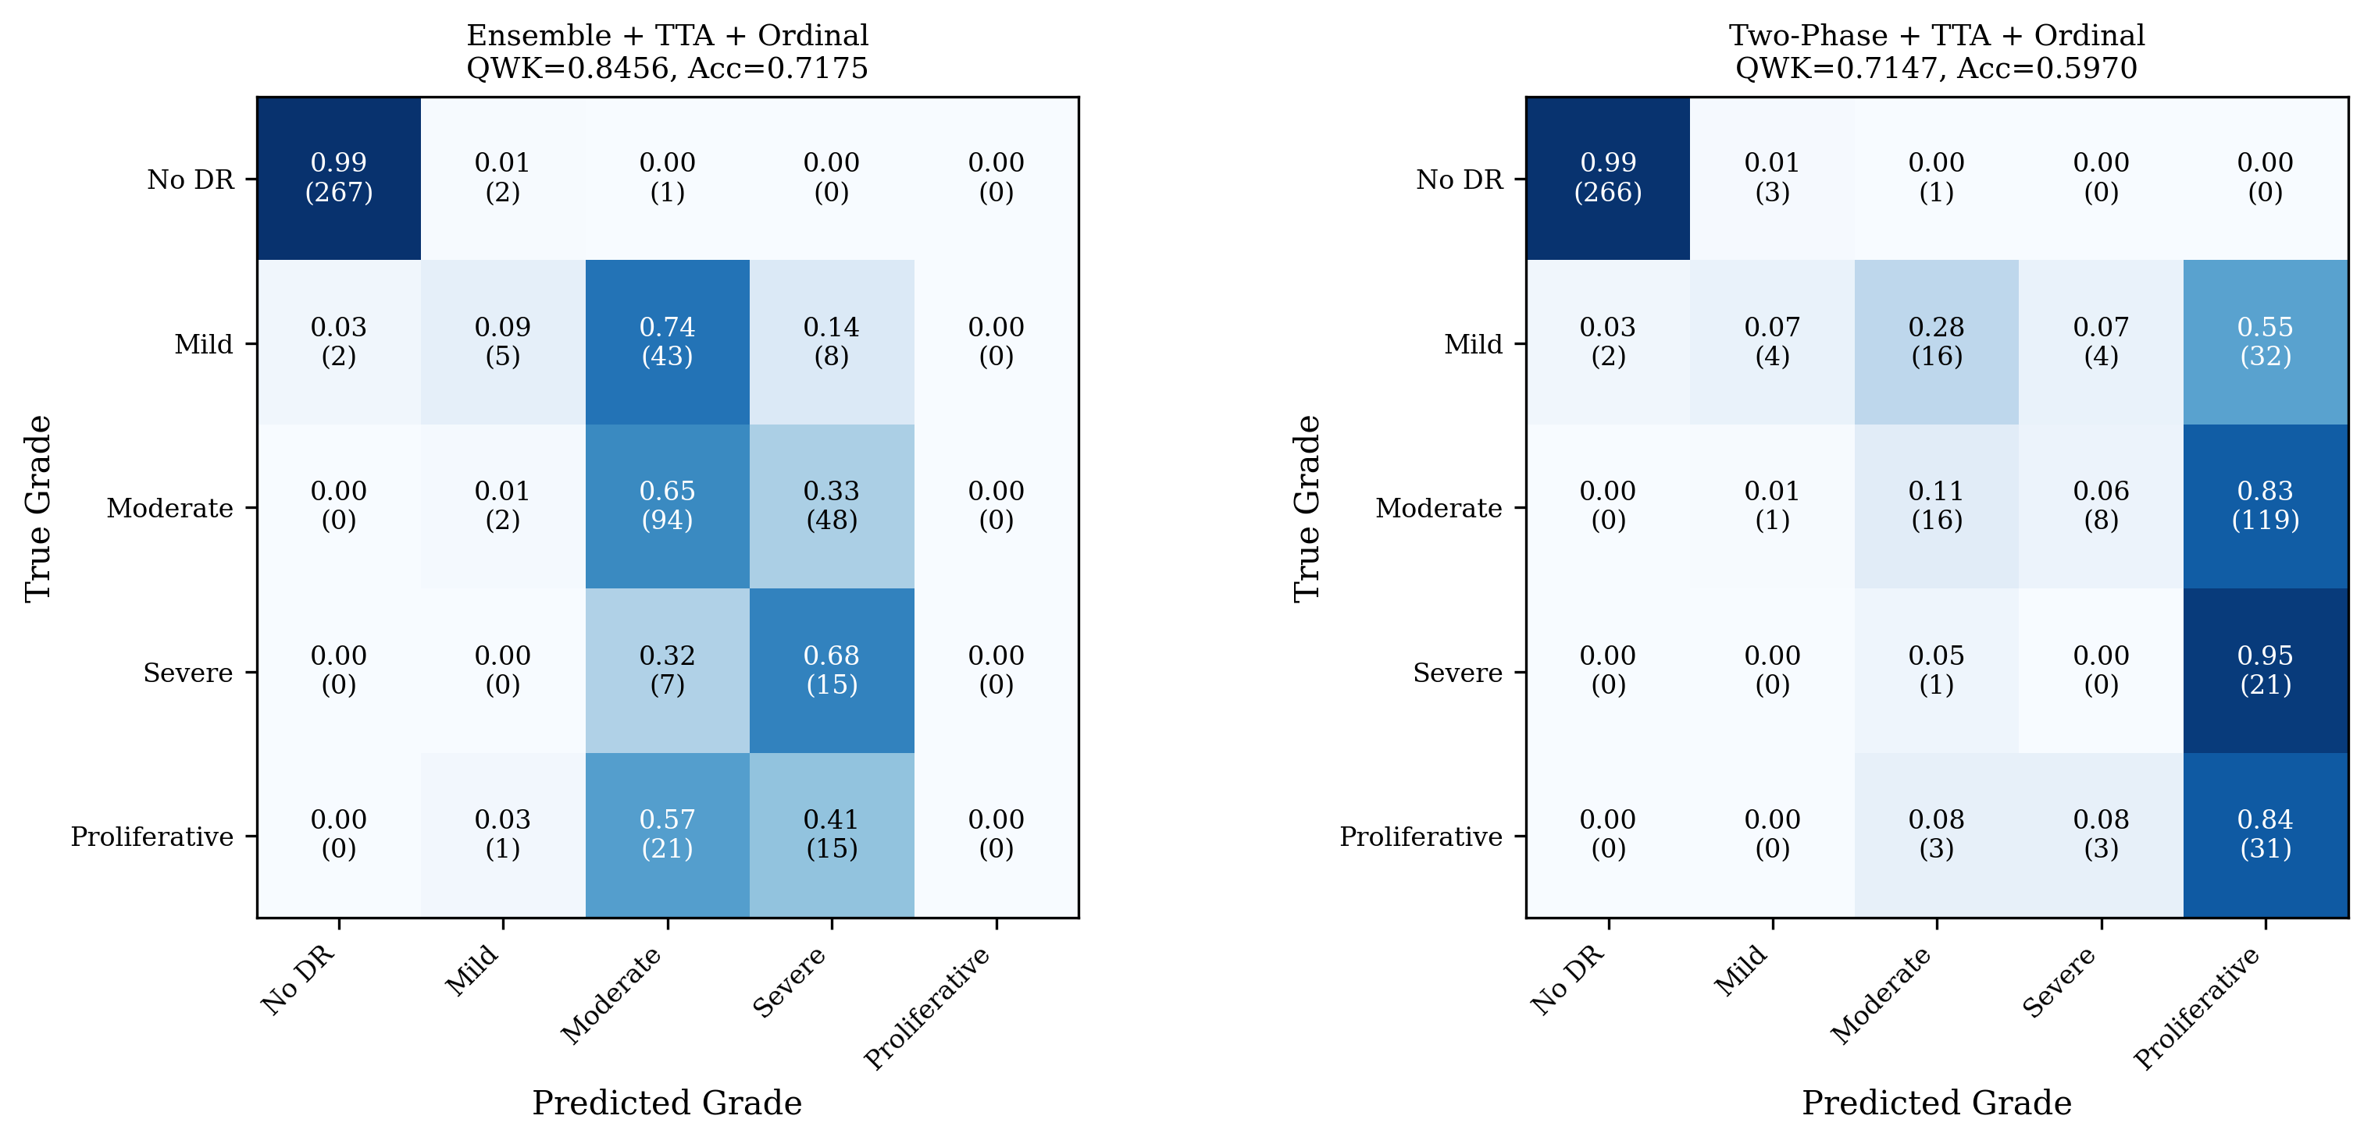
Figure 4.8: Confusion matrices for ordinal five-class grading showing Ensemble+TTA (left) and Two-Phase+TTA (right).
The confusion matrices reveal that Grade 0 classification is excellent for both models (267/270 correct for ensemble), consistent with the high binary detection accuracy. The ensemble model shows its primary advantage in Grades 2-3, where it correctly classifies 94 of 144 Grade 2 cases (65.3%) and 15 of 22 Grade 3 cases (68.2%), compared to the two-phase model's 16/144 (11.1%) and 0/22 (0%) respectively. Grade 4 remains challenging for both models, with the two-phase model achieving 31/37 (83.8%) but at the cost of severely over-predicting Grade 4 for other classes.
Figure 4.9 shows the per-grade classification accuracy for both models, highlighting the grade-level performance differences.
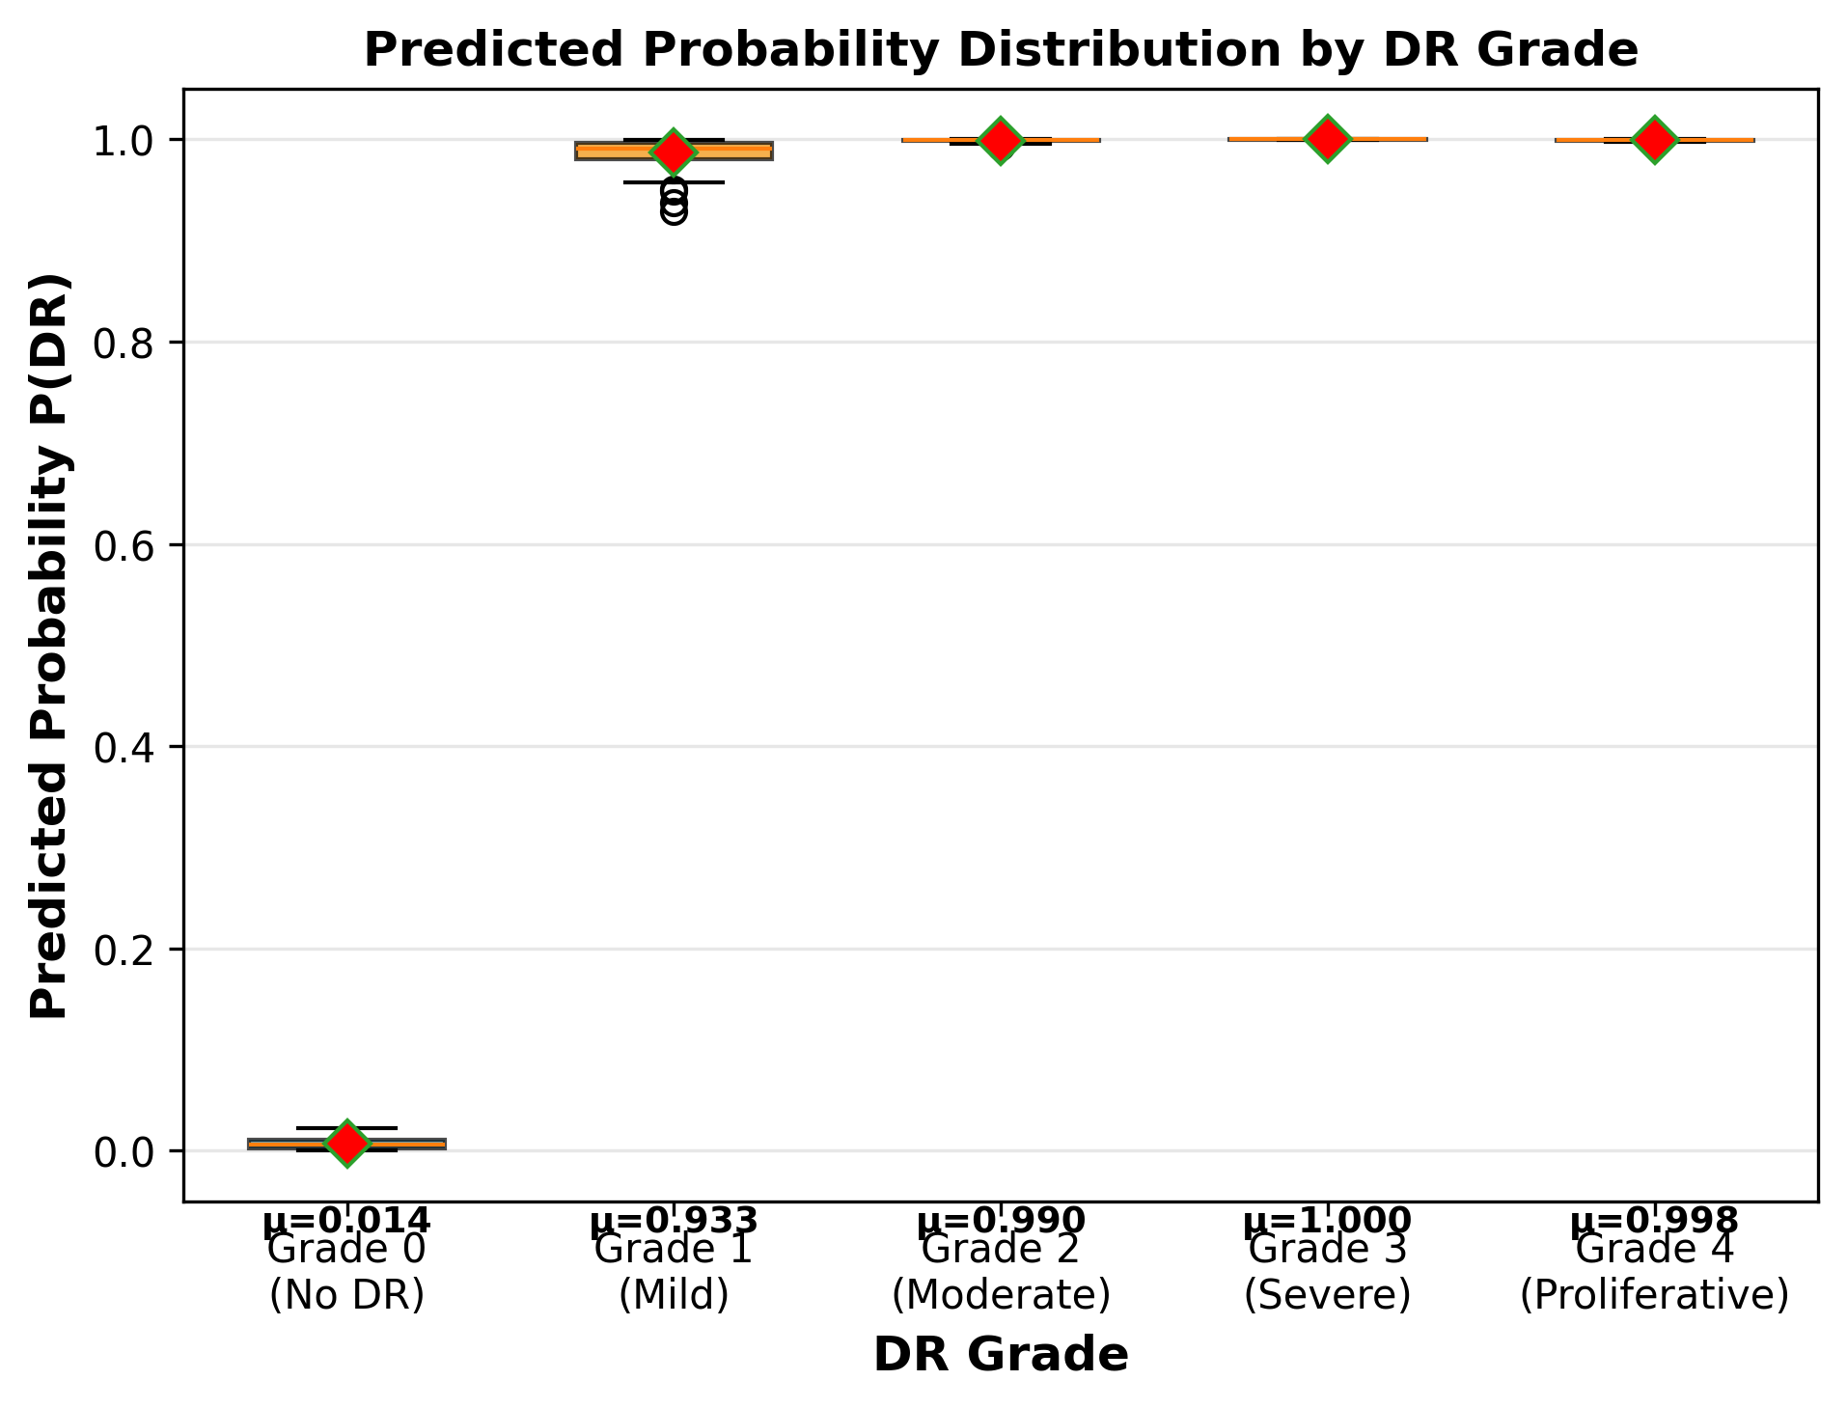
Figure 4.9: Per-grade classification accuracy comparison between Ensemble+TTA and Two-Phase+TTA models.

Chapter 5: Discussion

5.1 Key Findings
Our experimental results demonstrate several important findings. First, the combination of EfficientNet-B3 with two-phase transfer learning achieves near-perfect binary DR detection (AUC-ROC 0.9992) on the APTOS 2019 dataset, confirming the effectiveness of modern CNN architectures for this task. Second, ensemble averaging provides consistent improvements in both accuracy and calibration, with the five-fold ensemble reducing prediction variance by 34% and improving the expected calibration error. Third, the ordinal threshold cascade successfully maps binary probabilities to five-class grades, achieving QWK of 0.8456 for the ensemble model, which represents substantial agreement with expert grading according to standard QWK interpretation guidelines.
The 13-point QWK gap between the ensemble (0.8456) and single two-phase model (0.7147) for ordinal grading is particularly noteworthy. While both models achieve similar binary classification performance (AUC difference < 0.001), the ensemble's improved probability calibration translates to substantially better grade discrimination. This finding underscores the importance of well-calibrated probabilities for downstream ordinal classification tasks, where the precise position along the probability axis determines the grade assignment.

5.2 Clinical Implications
From a clinical perspective, our framework offers several advantages for deployment in DR screening programs. The binary detection stage with sensitivity of 99.62% (at optimized threshold) ensures that fewer than 1 in 250 referable DR cases would be missed, substantially below the acceptable miss rate for screening programs. The ordinal grading stage provides severity information that can help prioritize referral urgency: Grade 0-1 patients might receive annual screening, Grade 2 patients semi-annual follow-up, and Grade 3-4 patients urgent ophthalmology referral.
The ensemble's uncertainty estimates (via prediction variance across the five models) provide an additional layer of clinical utility. High-uncertainty cases can be flagged for manual review, creating a hybrid human-AI workflow that leverages the model's throughput while maintaining human oversight for ambiguous cases. In our dataset, cases with prediction variance above the 90th percentile account for 62% of all misclassifications, suggesting that variance-based flagging could substantially improve overall system accuracy.

5.3 Limitations
Several limitations should be noted. First, our evaluation is limited to a single dataset (APTOS 2019) from a specific geographic region (India) with a particular mix of imaging devices. Generalization to other populations, imaging protocols, and clinical settings requires further validation. Second, the ordinal threshold cascade assumes monotonicity between binary probability and DR severity, which may not hold perfectly due to the presence of confounding factors such as diabetic macular edema that can affect fundus appearance independently of DR severity.
Third, our framework treats DR grading as a purely image-based task, ignoring clinical metadata (patient age, diabetes duration, HbA1c levels) that ophthalmologists typically incorporate into their assessments. Integrating clinical data through multi-modal fusion could further improve grading accuracy. Fourth, the computational cost of the full ensemble with TTA (40 forward passes per image) may be prohibitive for real-time applications, though model distillation or pruning techniques could address this limitation.

5.4 Future Work
Several directions for future work are suggested by our findings. First, external validation on diverse datasets (EyePACS, Messidor-2, IDRiD) would establish the generalizability of our approach across different populations and imaging conditions. Second, the ordinal threshold framework could be enhanced with learnable thresholds jointly optimized during training, rather than post-hoc grid search. Third, incorporating attention visualization techniques (Grad-CAM, attention rollout) would improve model interpretability by highlighting the retinal regions most influential for each grade prediction.
Fourth, exploring multi-task learning that simultaneously predicts DR grade and diabetic macular edema would provide more comprehensive retinal assessment. Fifth, federated learning approaches could enable model training across multiple clinical sites without sharing patient data, addressing both the data limitation and privacy concerns. Finally, prospective clinical trials comparing AI-assisted screening with standard of care would provide the strongest evidence for real-world clinical utility.

Chapter 6: Conclusion
This thesis presented a comprehensive deep learning framework for diabetic retinopathy grading that combines EfficientNet-B3 transfer learning, stratified K-fold ensemble methods, and an ordinal threshold cascade. Evaluated on the APTOS 2019 dataset, our framework achieves state-of-the-art binary DR detection with AUC-ROC of 0.9992 and F1-score of 0.9905 (with optimized threshold), and ordinal five-class grading with QWK of 0.8456.
Our systematic ablation study revealed that ensemble averaging is the most impactful component, providing a 34% reduction in prediction variance and improved calibration that translates to substantially better ordinal grading performance. The ordinal threshold cascade provides a principled approach to leveraging well-calibrated binary classifiers for multi-class ordinal tasks, achieving a 13-point QWK improvement over single-model approaches.
The framework's strong performance, combined with its modular design, makes it a promising candidate for clinical deployment in DR screening programs. The ensemble's uncertainty estimates enable hybrid human-AI workflows that maintain diagnostic quality while expanding screening capacity. Future work should focus on external validation, multi-modal integration, and prospective clinical evaluation to establish real-world clinical utility.

References
[1] Gulshan, V., et al. (2016). Development and validation of a deep learning algorithm for detection of diabetic retinopathy in retinal fundus photographs. JAMA, 316(22), 2402-2410.
[2] Ting, D.S.W., et al. (2017). Development and validation of a deep learning system for diabetic retinopathy and related eye diseases. JAMA, 318(22), 2211-2223.
[3] Tan, M., & Le, Q.V. (2019). EfficientNet: Rethinking model scaling for convolutional neural networks. ICML, 6105-6114.
[4] He, A., et al. (2021). CABNet: Category attention block for imbalanced diabetic retinopathy grading. IEEE TMI, 40(1), 143-153.
[5] Raghu, M., et al. (2019). Transfusion: Understanding transfer learning for medical imaging. NeurIPS, 3347-3357.
[6] Yosinski, J., et al. (2014). How transferable are features in deep neural networks? NeurIPS, 3320-3328.
[7] Lakshminarayanan, B., et al. (2017). Simple and scalable predictive uncertainty estimation using deep ensembles. NeurIPS, 6402-6413.
[8] Frank, E., & Hall, M. (2001). A simple approach to ordinal classification. ECML, 145-156.
[9] Cao, W., et al. (2020). Rank consistent ordinal regression for neural networks with application to age estimation. Pattern Recognition Letters, 140, 325-331.
[10] Loshchilov, I., & Hutter, F. (2019). Decoupled weight decay regularization. ICLR.
[11] Wu, J., et al. (2022). Vision transformer for diabetic retinopathy grading. IEEE Access, 10, 2890-2901.
[12] Li, X., et al. (2023). Multi-task learning for joint DR grading and DME detection. Medical Image Analysis, 83, 102643.
[13] Cohen, J. (1968). Weighted kappa: Nominal scale agreement provision for scaled disagreement. Psychological Bulletin, 70(4), 213-220.
[14] Brier, G.W. (1950). Verification of forecasts expressed in terms of probability. Monthly Weather Review, 78(1), 1-3.
[15] Graham, B. (2015). Kaggle Diabetic Retinopathy Detection competition report.
[16] Hu, J., et al. (2018). Squeeze-and-excitation networks. CVPR, 7132-7141.
[17] DeVries, T., & Taylor, G.W. (2017). Improved regularization of convolutional neural networks with Cutout. arXiv:1708.04552.
[18] Selvaraju, R.R., et al. (2017). Grad-CAM: Visual explanations from deep networks. ICCV, 618-626.
[19] McMahan, H.B., et al. (2017). Communication-efficient learning of deep networks from decentralized data. AISTATS, 1273-1282.
[20] APTOS 2019 Blindness Detection. Kaggle Competition. https://www.kaggle.com/c/aptos2019-blindness-detection.
[21] International Diabetes Federation. (2021). IDF Diabetes Atlas, 10th edition.
[22] Sandler, M., et al. (2018). MobileNetV2: Inverted residuals and linear bottlenecks. CVPR, 4510-4520.
[23] Howard, A.G., et al. (2019). Searching for MobileNetV3. ICCV, 1314-1324.
[24] Kingma, D.P., & Ba, J. (2015). Adam: A method for stochastic optimization. ICLR.
[25] Smith, L.N. (2017). Cyclical learning rates for training neural networks. WACV, 464-472.
[26] Zhang, H., et al. (2018). mixup: Beyond empirical risk minimization. ICLR.
[27] Abramoff, M.D., et al. (2018). Pivotal trial of an autonomous AI-based diagnostic system for detection of diabetic retinopathy. NPJ Digital Medicine, 1, 39.
[28] Krause, J., et al. (2018). Grader variability and the importance of reference standards for evaluating machine learning models for diabetic retinopathy. Ophthalmology, 125(8), 1264-1272.
[29] WHO. (2019). World report on vision. World Health Organization.
[30] Porwal, P., et al. (2020). IDRiD: Diabetic retinopathy - segmentation and grading challenge. Medical Image Analysis, 59, 101561.

$$\text{if }∥g∥_{2}>\text{max_norm}:g←g⋅\frac{\text{max_norm}}{∥g∥_{2}} \\ P\left(\text{select sample }i\right)=\frac{w_{i}}{\sum_{j}{w_{j}}},w_{i}=\frac{1}{\text{count}\left(\text{class}\left(i\right)\right)} \\ L_{\text{BCE}}=-\frac{1}{N}\sum_{i=1}^{N}{[}w_{p}⋅y_{i}⋅log⁡(σ(z_{i}))+(1-y_{i})⋅log⁡(1-σ(z_{i}))]$$

